|  |  |
| --- | --- |
| Lab 12 | AS.020.674 Spring 2017 |
|  |  |

Due May 12. Submit the output of your CellProfiler project for each of the problems.

**Introduction**

In this lab you will be learning how to use the cell profiler (<http://www.cellprofiler.org>) tool to quantify microscopy images of cells.

1) Read an introduction to automated image analysis:

<http://www.ploscompbiol.org/article/info:doi/10.1371/journal.pcbi.1000603>

2) Go through these two video tutorials:

* Getting started with CellProfiler:  
  <https://youtu.be/OEHYXdOINg0?list=PL7CC87670239B4D10>
* CellProfiler: Constructing pipelines  
  <https://youtu.be/PEaiGs18AF0?list=PL7CC87670239B4D10>

3) Download the TranslocationData_CP_CPA_Exercise.pdf file and TranslocationData folder from the course website. Go through the exercise to learn how to use Cell Profiler. Note: the download link for the data given in the PDF file no longer works, you should use the data you downloaded from the course website in its place.

*You do not need to submit answers to the questions in the above exercise.*

You may want to consult the manual as you work through the exercise to understand what different options mean:

<http://www.cellprofiler.org/manuals.shtml>

There are also many example pipelines and image available here:

<http://www.cellprofiler.org/examples.shtml>

And additional tutorials available here:

<http://www.cellprofiler.org/tutorials.shtml>

**Lab assignment**

In this lab you will be analyzing fluorescence images of human HT29 cells.

**Images**

Download the two images from Blackboard. The file nuclear_stain.tif is an image with data from the fluorescence channel of the nuclear marker and the file cytoplasm_stain.tif is an image with data from the cytoplasmic marker fluorescence channel.

**Problem 1**

Create a CellProfiler pipeline for analyzing the images. Segment the nuclei and cells from the images. Find the optimal settings for the modules to segment the images. Turn in the output of your IdentifyPrimaryObject and IdentifySecondaryObject pipeline modules. Your segmentations should look something like these:

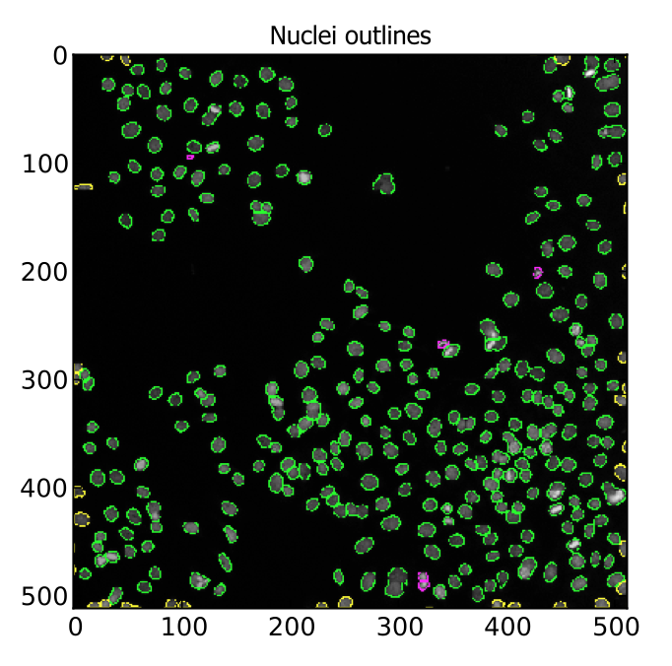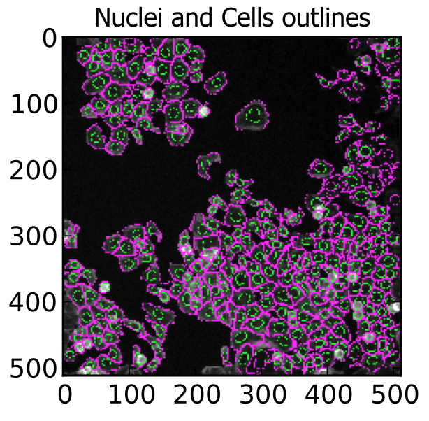

**Problem 2**

Plot two histograms: one of the distribution of areas of the nuclei and the other of the distribution of areas of the full cell. Hint: use the DisplayHistogram pipeline module.

**Problem 3**

Plot two histograms: the integrated fluorescence intensity of each nuclei and each cell.

**Problem 4**

Plot a scatter plot (DisplayScatterPlot) of the integrated fluorescence intensity of each nuclei versus the area of the nuclei. Based on this plot do you think that the integrated fluorescence intensity is an unbiased reporter for the signal? Why or why not? If not, what might you use instead?